**Stability of Lunar Lagrange Point L2**

**Conor Diver | Durham University | 9th November 2020**

There are stationary solutions for the circular restricted 3 body problem known as the Lagrange points of an orbit.

The restricted 3 body problem involves 2 massive objects of masses $M_{1}$ and $M_{2}$ orbiting about a common centre of mass with period $P$, and a third object with negligible mass, $m$, moving within the system’s gravitational potential.

These Lagrange points exist where the net force on an object in the comoving frame ($ω=\frac{2π}{P}$) is zero. This can also be represented by the stationary solutions of the system potential.

$$ϕ=-G(\frac{M_{1}}{r_{1}}+\frac{M_{2}}{r_{2}}) - \frac{1}{2}r^{2}ω^{2}$$

$$F = -m∇ϕ = 0$$

Three of these stationary points are saddles, and thus are unstable (L1, L2, L3) and an additional 2 stationary points exist when the condition $\frac{M_{1}}{M_{2}}>24.96$ is met, and are stable maxima (L4,L5).

**Lagrange Points**

POSTER

1 min summary – include aim of work etc, don’t go into too much detail.

REPORT

-6 pages, use lab template,

-no error appendix required – discuss errors in text

-Similar sections to lab report

-Code not required to be submitted

-Results and discussion may be merged

**Earth-Moon 3 Body Problem**

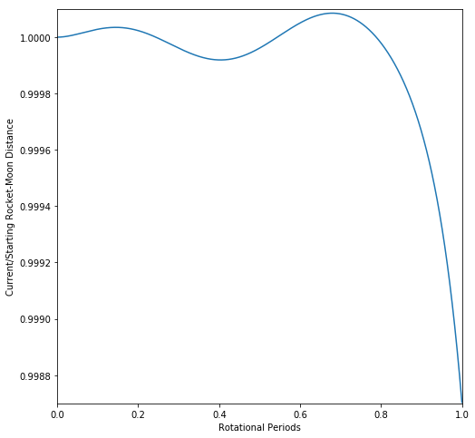­­ ­­

The period of an object at a Lagrange point is equal to that of the orbital system, hence they maintain a constant distance from either massive object. In the Sun-Jupiter system, this results in asteroids at L4 and L5 closely following Jupiter in its orbit – these are known as the Trojans.

Object orbits can also follow equipotential lines (FIG 1) around these Lagrange points, meaning multiple asteroids can oscillate about the stable point, with varying degrees of stability.

One class of orbit are the extremely stable Tadpoles, which follow contours close to one of L4 or L5. Their orbit draws out a tadpole shape in the comoving frame.

Another class of orbit are the quasi-stable Horseshoes, which follow contours encapsulating both L4 and L5. These contours sit between the Tadpoles, and the regions where asteroids cannot orbit. Their orbit draws out a horseshoe shape in the comoving frame.

Today, almost every Trojan follows a variation of the Tadpole orbit, with no known Horseshoe orbits currently existing.

**Sun-Jupiter Trojans**

The Earth-Moon orbital system meets the conditions for all 5 Lagrange points, with a mass ratio of $\frac{M_{1}}{M_{2}}=81.$ 28. L1, L2, and L3 are shown by saddle point contours, and correspond to the maxima of the gravitational potential in space along the x=0. L4 and L5 are shown by contour maxima, and correspond to gravitational potential maxima along y=1.87e8.

**FIG.1: Earth-Moon Gravitational System**

At an initial distance of $∆r=$ 64522900*m*, the orbit of the rocket remained mostly stable for the first period – remaining between 1.0001 and 0.9987 times the initial $∆r$. However, as time progresses the rocket begins to leave the unstable L2 zone and spirals out of a stationary orbit. It begins to loop around the Moon between periods 1 and 2, and then proceeds to enter a close Earth orbit for an additional 3 periods. This clearly shows the instability of the L2 point – that even a small perturbation of $≈1\%$ can lead to departure from the orbit after only 1 full orbital period.

**FIG.2: Rocket-Moon Distance Over Time**

The initial distance used, $∆r=$ 64522900*m*, is approximately 6% larger than the value suggested in equation **(4)**. This is expected, as the equation provides an estimation of the position of L2. The stability of the orbit is extremely sensitive to even slight perturbations from the optimal position, hence deviation from the estimate is required for a stable orbit.

The initial fluctuations in the first orbital period, as shown in **FIG.2**, suggest that more precision is required when simulating the orbits of the Earth, Moon, and rocket. A smaller time step between gravitational simulations will provide a more continuous path for the rocket to follow and reduce deviation of the rocket from the rocket-Moon distance. However, if the initial proximity of the rocket to the L2 point is not sufficiently accurate, the rocket will still spiral out of a stable orbit as time goes on.

**Discussion Of Results**

References: [1] Tipler, *Modern Physics*, 6th edition, W.H. Freeman (2012), Pages 62-65 **|** [2] *The Lagrange Points*, 2012, WMAP, [map.gsfc.nasa.gov/ContentMedia/lagrange.pdf] as of Nov 2020